**“Database Management System for Health Care”**

**Objectives: -**

• To create a database of medicine for different kind of diseases.

• Design Software to suggest medicine and prevention from the disease.

**Abstract:-**

Health Care Database will have the information of diseases, symptoms, causes, medicines prescription and their composition.

Work on Web development and program the database using html, CSS, JAVASCRIPT, PHP and MySQL.

It will provide the user to create their login id and search medicine through name of disease and through the name of symptoms.

User will be provided with the option of adding new relevant data, which will be cross verified and we will update our database.

It will also suggest prevention of disease and take the feedback from user of their experience on our software.

**Home Page**



**Search box for Search by Disease**

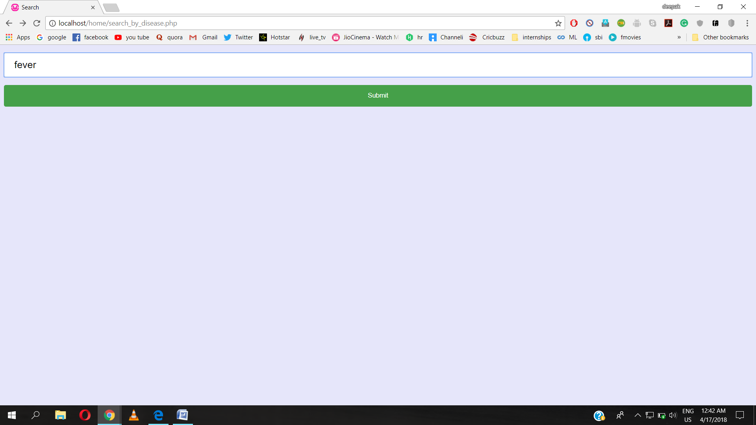

**Result of above search (search by Disease)**

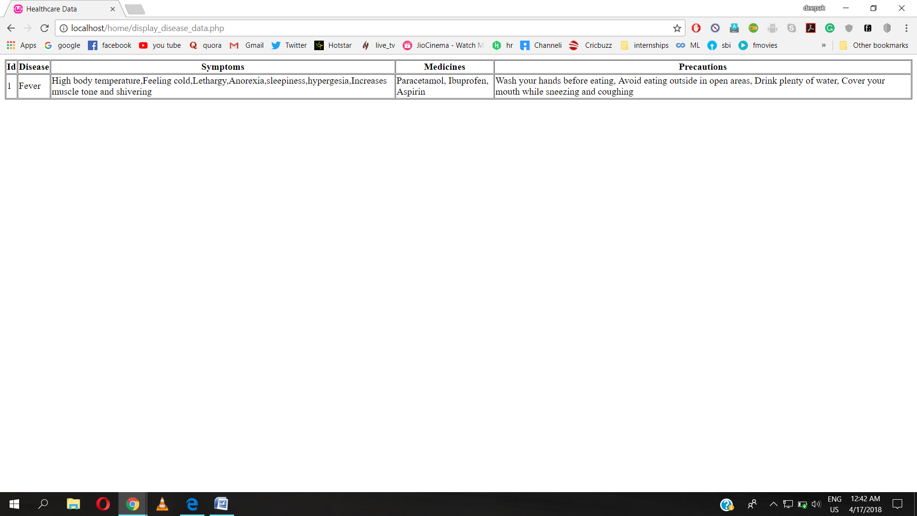

**Result for search By Symptoms:-** This search is programmed for an instant search. As we change the content of search box, the result changes instantaneously.

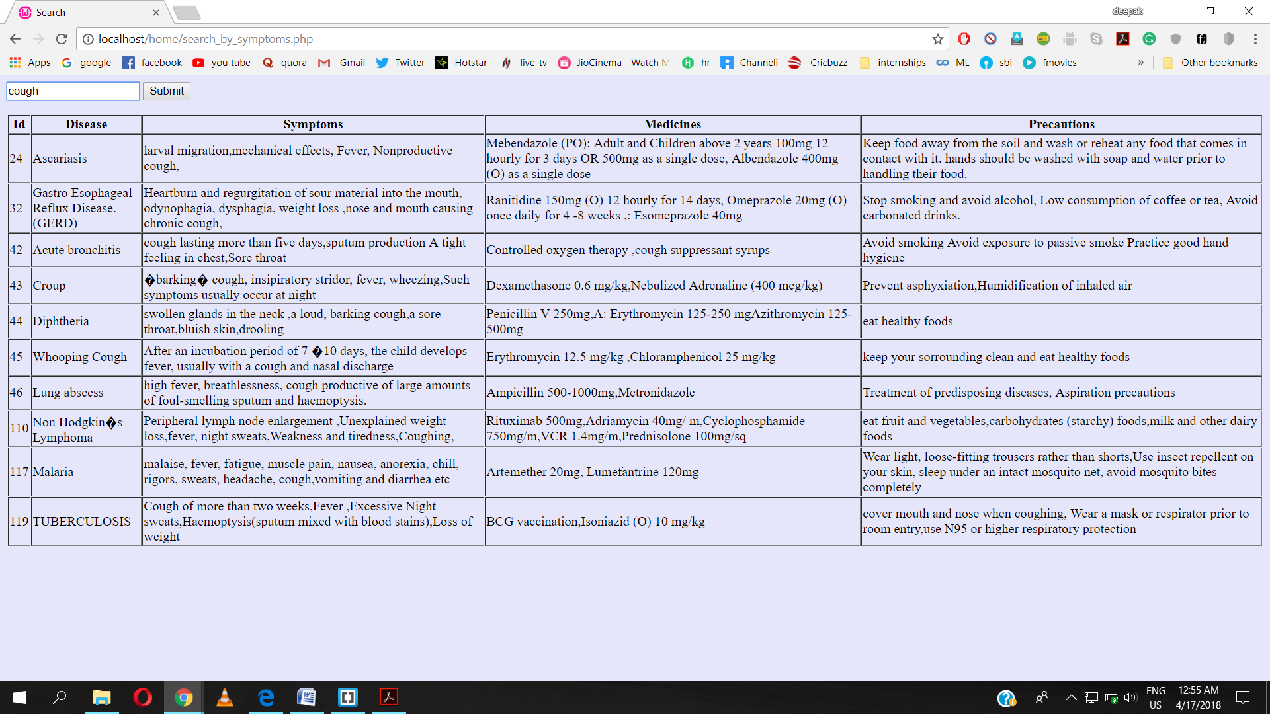

**Login Page**

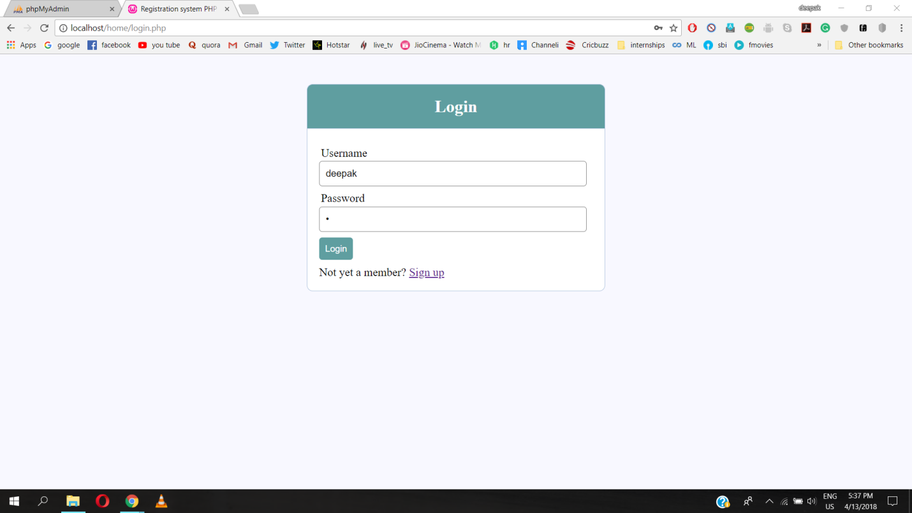

**Signup Page**

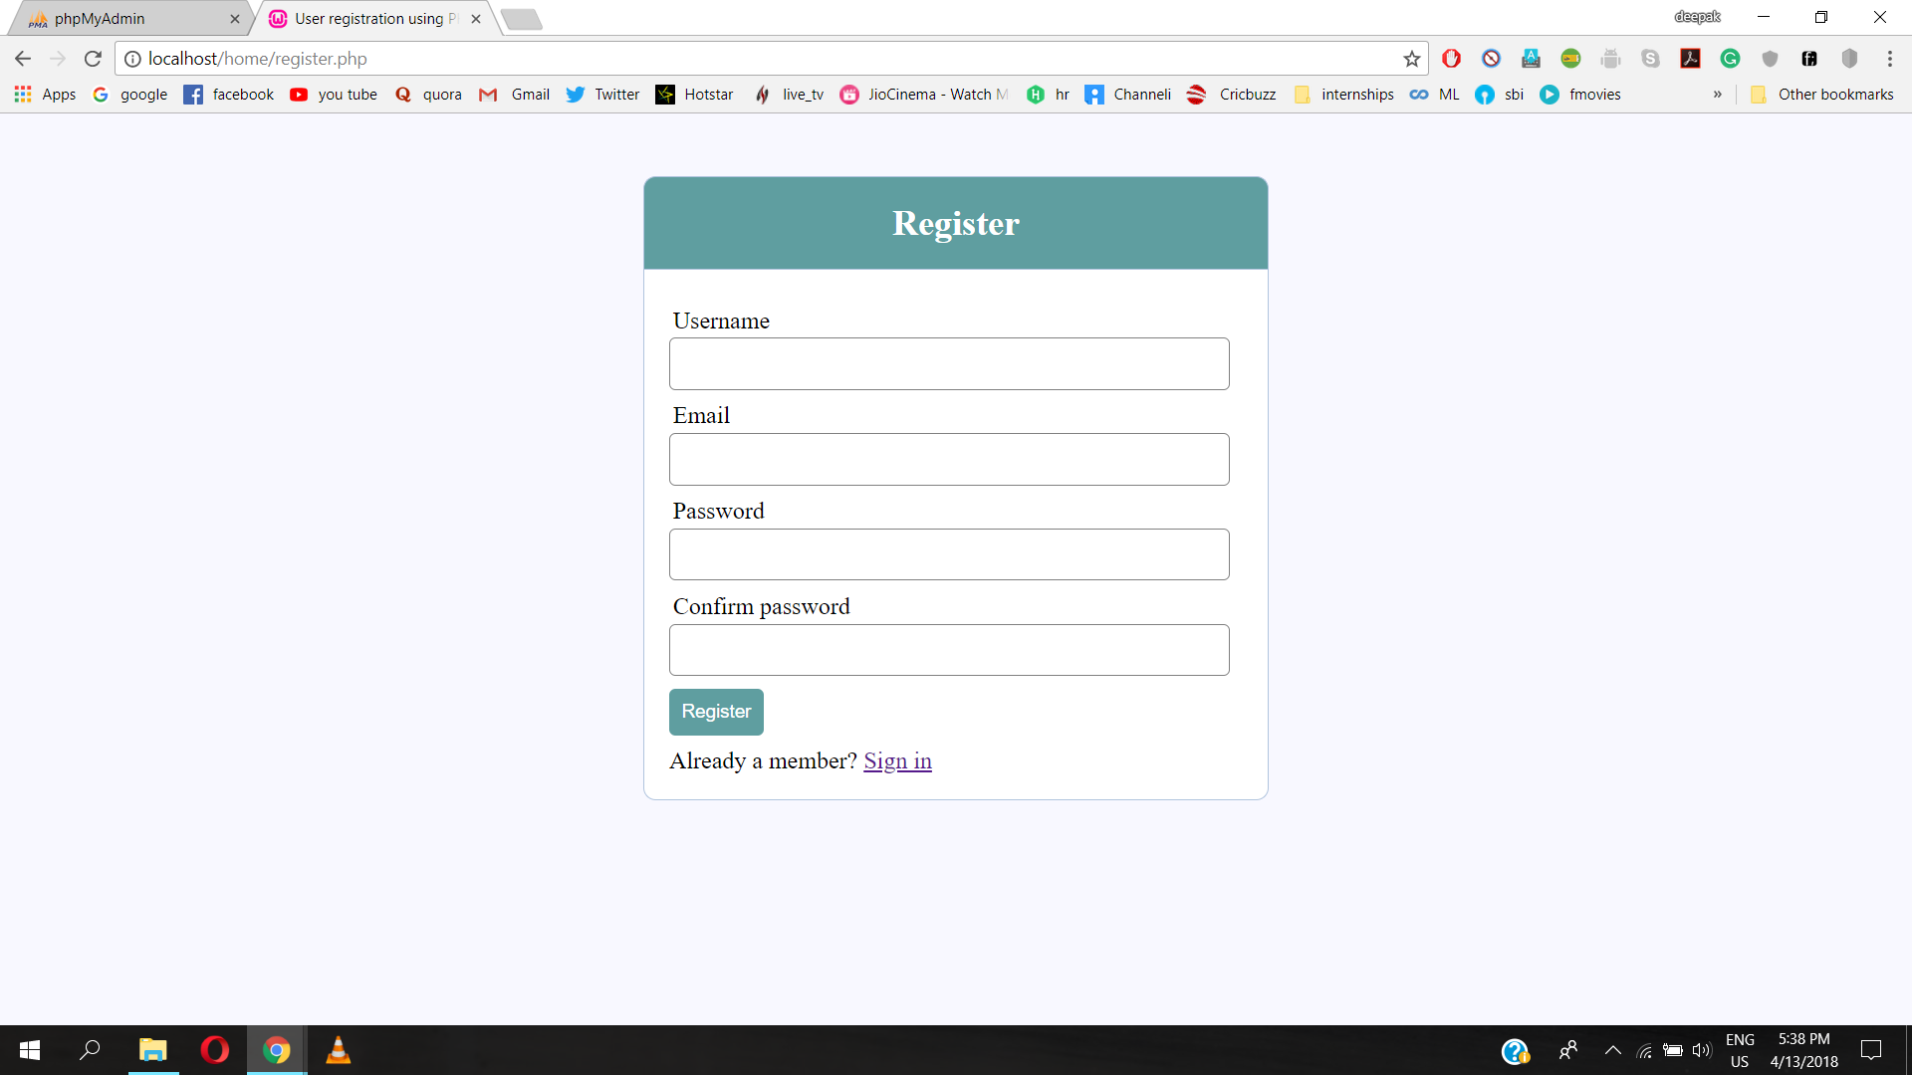

**Sample Database**

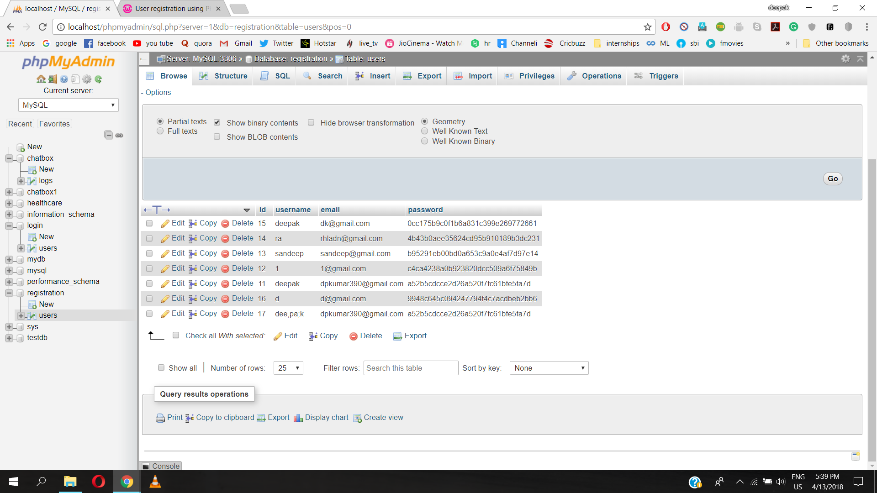

**Note:-**Project is almost 70% done. It is tested on sample database and it is working properly. Some backend works are still to be done along with front end designing of few pages.